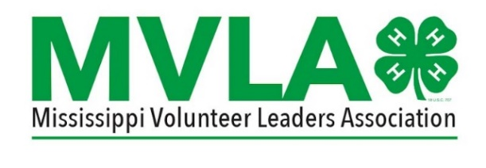

MISSISSIPPI 4-H VOLUNTEER LEADERS’ ASSOCIATION OFFICER NOMINATION FORM
All MVLA elected officers will be voted on during the Business Meeting held at the Annual 4-H Volunteer Leaders’ Association’s Leadership Conference according to the following schedule: The President-Elect and Secretary will serve two year terms and will be elected on even years. The Treasurer will serve a two year term and will be elected on odd years. The Vice-President and Parliamentarian will be elected annually.
Four (4) Assistant District Coordinators will also be elected by MVLA members from their specific Extension District during the Business Meeting held at the Annual 4-H Volunteer Leaders’ Association Leadership Conference. Assistant District Coordinators must live in their respective District and must be a member of MVLA. This position is a three (3) year term in which they will serve their first year as Assistant District Coordinator, their second year as the District Coordinator-Elect, and their third year as the District Coordinator.
Nominees must be present at the MVLA Annual Business Meeting and be prepared to present a (3) minute speech. Nominees must be a Registered 4-H Volunteer Leader.
Nominations must be received in the State 4-H office by February 23, 2024.
Email completed form to Debra Lloyd at dpl4@msstate.edu.

MISSISSIPPI 4-H VOLUNTEER LEADERS’ ASSOCIATION OFFICER NOMINATION FORM
Please complete the information below:
I, _________________________________ recommend: _____________________________________
From _____________________________County: to serve as:
Please check one:
President-Elect_________ Vice President _________
Secretary ___________ Treasurer __N/A_______
Parliamentarian _________ Assistant District Coordinator _________ Region___________
Nominee’s Address: _________________________________________________________________
Nominee’s Telephone Number: _____________________________________________________
Number of Years Served as a 4-H Volunteer: ________________________________________
List major qualifications of the volunteer (include previous experience on similar committees in the county or in other organizations – attach additional pages if necessary).

Nominator’s Signature: ______________________________________ Date__________________
Extension Agent Signature: ___________________________________Date__________________
Email completed form to Debra Lloyd at dpl4@msstate.edu by February 23, 2024.

