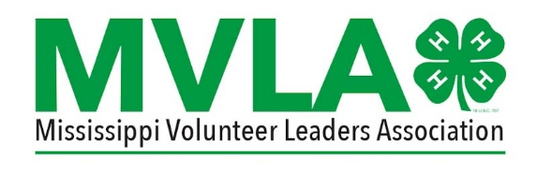
Mississippi 4-H Volunteer Leaders’ Association Outstanding 4-H Volunteer Leader of the Year
Nomination Form
Due February 23, 2024
Recognizing volunteers for their hard work and dedication is very important to the 4-H Youth Development Program. Every county has outstanding 4-H Volunteer Leaders who should be considered for these special awards.
The Outstanding 4-H Volunteer Leader Nomination Form must be filled out for each applicant and submitted via e-mail to the State 4-H office. As this is a very competitive award, letters of support and detailed information about the nominee’s 4-H Volunteer work are encouraged.
Recipients will be recognized at the Annual 4-H Mississippi Volunteer Leaders’ Association Banquet, which will be held on March 15, 2024, at the Mississippi State University Bost Building B Conference Center.
Check the Award Category Below:
( ) Harvey Gordon Rising Star Outstanding Volunteer Leader Award (1-3 Years of service)
( ) Outstanding Volunteer Leader of the Year Award (4–10 Years of service)
( ) Ruby Beckley Lifetime Outstanding Volunteer Leader Award (Over 10 Years of service)

Please print or type Nominee information:
Name |  |  | Region
Address |  |  | City
County |  |  | Zip

In 100 words or less, explain why this Volunteer Leader deserves this award (pertaining to 4-H).
Please include any other information you feel qualifies this volunteer to receive this award (can include awards, leadership offices, community service, testimonials, attached letters of recommendation, etc – can attach additional pages)

Nominator’s Name _______________________________ Region _________________________

Nominator’s Address______________________________ City ____________________________
County___________________________________________ Phone __________________________

Nominator’s Signature _____________________________________ Date_____________________

Email completed form to Debra Lloyd at the State 4-H office at dpl4@msstate.edu by February 23, 2024.

